Java Application source Code: It compiles to Application Bytecode and is where you have Third-party libraries and the Standard Edition APIs

Runtime Environment: where the java complies in java virtual machine. It is where it runs the java bytecode which then has to us JVM to run in machine code.(JDK)

Class decleration-Groups the code inside a curly braces.

Main Method- “public static void main(String [] args)”

Bytecode > Java Standard Edition(SE) > Java Virtual Machine (JVM)

JavaFX

Spring Framework. Spring decouples the classes from each other so the Application, Helper, and Utility class can be separated especially useful for testing.

Java Utility Libraries: Google Guava; Apache Commons(Collections, CSV, IO); Apache Log4J(logging statements)

Java Distributed System Libraries: Netty, Akka, RxJava(Reactive Programming), Apache Camel(Wiring together existing systems)

Java Data-access Libraries- Java Database Connectivity(JDBC) most applications can communicate with the databases. JDBC are low level so ORMs are used for more task libraries like Hibernate and Eclipse Link. Sql DSLs they use SQL commands in Java libraries like JOOQ, and QueryDSL

Maven-Uses xml to make a java code,

Gradle- It is used for build tools with java

Jenkins is used as a CI tool for Java programs and makes sure they run on a server.

Tools: Checkstyle, Spotbugs, PMD is used to scan at a source code level.

SonarQube is also used to keep track of code analyzing.

Alternative Languages of Java: Groovy, Scala, Kotlin-Came out after Scala, google endorses it for android development, it also runs in the browser.

JDK is used to make a Java App. C can run directly on the computer. Java Runtime Enviroment allows the java app to run.

JavaDoc (future program) Comments /** …. */

Java Comments: // for a single line

/* … */ for multiple line comments

Packages for java:

Uses reverse domain name ie pluralsight.com is package com.pluralsight

Members become part of a package, name of the member has to be unique or it will overwrite the previously existing one.

Package names need to add up to the folder layout of a package.

Base Package on the IDE will setup the package name to make sure the layout is accurate.

**Variables**

Primitive Data Types= Integer, Floating point, Character, Boolean

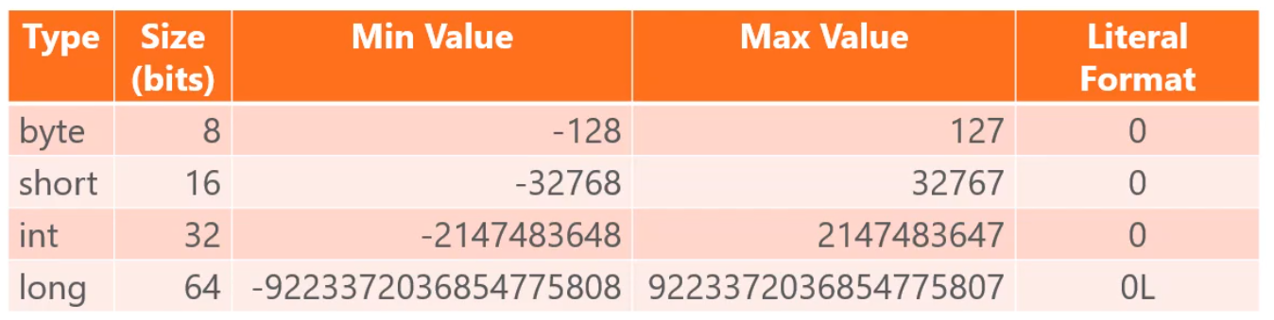

For Long numbers you have to put a capital L at the end of it.

For floating point:

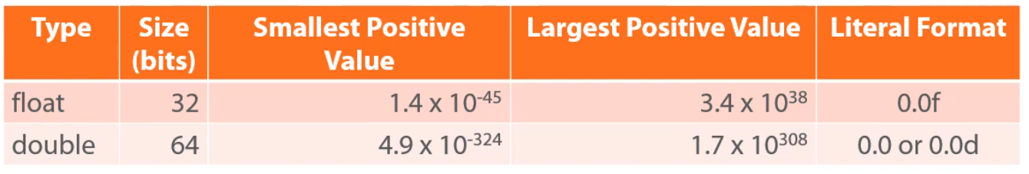

Floating points need an f at the end of them, double does not need a d at the end.

Character stores a single Unicode character and is noticed by single quotes.

Unicode character can be stored with the Unicode value

Prefix/Postfix Operators:

Prefix –a the value is changed prior to the rest of the formula

Postfix a++ the value is changed after the rest of the formula

Implicit type conversion which are automatically converted data types like int to long.

Explicit type conversion are performed by using cast operator:

Long iVal = 50; int val = (int) iVal; the () are the cast operator.

When you mix integer types it will convert to the largest integer type. That includes float, long and double.

If you convert from an integer to a floating point it can lose some digits.

For more information see widening and narrowing Primitive Conversion in the java documentation.

Conditional Operator:



Block statement groups statements in a compound statement. When you write an if statement you can write it in a singular line or have it over several lines.

The statements can be nested inside each other.

Class has Fields: which store an object state such as a variable. The Method has the executable code. Constructors are run during the object creation to set objects.

Classes are a reference type.

Three class modifiers: no access modifier, public (uses classes and members), private(use classes).